***Cryptic Chambers – Documentation***

**User Documentation**

1. **Introduction: What are you getting into?**
   1. *“Cryptic Chambers”* is a game made in Flowgorithm. It uses *Flowgorithm’s* file manipulation functionality and *VS Code’s* ability to view changes to files in real-time to create an illusion of a display.
   2. “Cryptic Chambers” consists of a menu-screen, giving you the option to select between Starting and playing the game, Viewing the Scoreboard, and Quitting the game on the spot.
   3. The goal is to pass all the mini-games, earning as many points as you can. Before every mini-game, on the loading screen, you can choose to stop playing, and save your gathered points, or proceed and risk losing everything you’ve got, with the possibility of getting even more points, as a reward.
2. **Requirements.**
   1. It is required that you have ***Flowgorithm*** and ***Visual Studio Code*** installed on your machine.
   2. Since there is a lot of code, a lot of instructions, and Flowgorithm is an interpreter, the program execution speed will vary based on your machine's performance. **Be warned that if you try to run this program on a slower machine, you will have trouble with it.**
3. **Setting up the game. (This documentation is made only for Windows. Mac documentation coming soon.)**
   1. If you’re not fond of reading documentations, a fast way to get started is by watching the video ***“SetupDemonstration.mp4”***, located in the folder ***“Cryptic Chambers/Additionals”***, which shows the setup process step by step.
   2. If, however, you want to read it, here are the same steps but in writing.
      1. Installing the custom font.
         1. Since we use VS Code with text files as our display. We don’t have much choice for aesthetics. But every problem has a solution. To work around this we created our own *Font*. Please before continuing forward, for *full game experience* run and install the ***“CrypticChamberss - Regular.otf”*** font located in ***“Cryptic Chambers/Additionals”*.** Although this step is not mandatory, it really adds to the game.
      2. Opening the folder **“Cryptic Chambers”** with VS Code.
         1. If you have installed VS Code with the option to “open a folder by right-clicking in the file-explorer”, then you have made your life easier. Simply open the folder, right click on an empty space and select *“Open with code”.*
         2. If however you were unlucky, open VS Code normally, click on File in the top right, click on open Folder and select the previously mentioned folder from whichever directory you’ve placed it in.
      3. Setting up VS Code as Display.
         1. Once opened, click the keyboard combination (“Ctrl + Shift + E”) to open the file explorer.
         2. Navigate your way through the files and open the file ***“Cryptic Chambers Display.txt”***, once opened, close other files and run the keyboard shortcut (“Ctrl + B”) to close the sidebar view so there is more space.
      4. Setting up Flowgorithm.
         1. After this, simply open the Flowgorithm project ***“Cryptic Chambers.fprg”*** normally. Now place the Flowgorithm project on the left half of the screen, and place the VS Code editor on the right half of the screen. Run the Flowgorithm project and place the console on the left side over the original project. This console will be your ***input field***, while the VS Code on the right will be your ***Display***.
      5. Outcome.
         1. If everything went well, you should be left with something like this: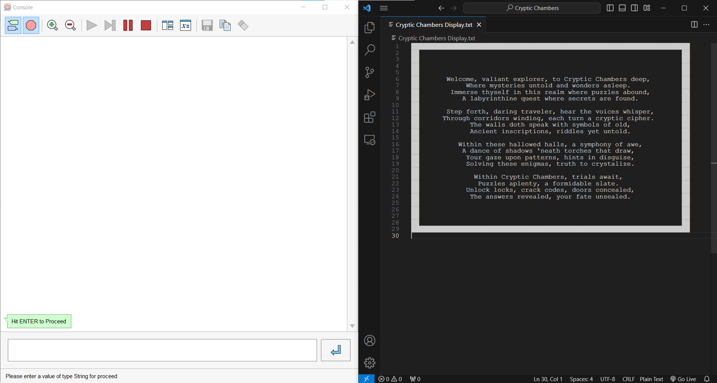

if your right side is smaller, or larger than expected. Click on VS Code and click the keyboard shortcut (“Ctrl + ‘+’”) or (“Ctrl + ‘-’”) until you’re happy with the outcome.

1. **How to play the game?**
   1. After starting the game, reading the introduction and proceeding forward, and entering your name, you will be met with 3 options, *Start Game*, *Scoreboard* and *Quit*. You can go through these options by typing “W” or “S” in the console and hitting enter to submit it. After choosing one of the Options, send an empty string by just hitting enter to choose that option.
   2. If you follow the instructions from the game itself, you should be fine. Main things you need to remember:
      1. In the maze, use W A S D to move. You can’t move through the white wall, only the black free space.
      2. In Tower of Hanoi, enter 1 continuous string of 2 characters “12” for example to move the top disk of tower 1 to the bottom free space in tower 2. You cannot move a bigger disk atop a smaller one. Your objective is to transfer the full tower on the third pole.
      3. In the wordsearch. Simply enter the word you find. Don’t worry about capitalization, only spelling.
      4. In Tic-Tac-Toe, write the index of the box you want to place an X in, 1 being the top left, 2 being the top middle and 4 being the middle left box. I’m sure you can figure out the order.
      5. Finally, if at any point you give up, write the string “QUIT” in the console. This will result in you losing all your points. Note: You cannot do this in the Tic-Tac-Toe, as it’s the final level, you can only play to win, lose or quit when you get a tie (this will not result in losing your points).
2. **Enjoy!**
   1. We, the creators of Cryptic Chambers, wish you best of luck on your gaming journey, and we hope you enjoy our game!!

**Developer Documentation**

|  |  |
| --- | --- |
| **File System** | |
| **Cryptic Chambers.fprg** | **Main Flowgorithm File** |
| **Cryptic Chambers Display.txt** | **Main Display file used by VS Code. This is the game’s Display.** |
| **Intro.txt** | **Introductory message to be displayed on the main Display to familiarize users with the storyline.** |
| **Outro.txt** | **Message to be displayed on the main Display after successfully finishing the whole game, completing the storyline.** |
| **Prompt_User_For_Name_Screen.txt** | **Message to be displayed on the main Display after the Intro to ask the user to input a name.** |
| **Level_Passed.txt** | **Message to be displayed on main Display every time a level is passed successfully.** |
| **Defeat.txt** | **Message to be displayed on main Display every time the user quits a level or loses at Tic-Tac-Toe.** |
| **Vicotry.txt** | **Message to be displayed on the main Display after successfully beating the Tic Tac Toe level** |
| **Farewell.txt** | **Message to be displayed on the main Display before quitting the game.** |
| **Quit_Empty_Screen.txt** | **An Empty text file that will clear the display after the Farewell message has been displayed.** |
| **Cryptic_Chambers_ASCII.txt** | **ASCII Art with the name of the game that will be displayed atop the Game Menu in the main Display.** |
| **Start_Game_Selected_ASCII.txt** | **The Game Menu with the Start Game Button selected.** |
| **Scoreboard_Selected_ASCII.txt** | **The Game Menu with the Scoreboard Button selected.** |
| **Quit_Selected_ASCII.txt** | **The Game Menu with the Quit Button selected.** |
| **Maze_Loading_Screen.txt** | **The Frame before the Zaze level, to be displayed on the main Display, period where the user can choose to proceed or stay safe.** |
| **Maze_Board.txt** | **The Maze starting position to be displayed on the main Display when the maze level begins.** |
| **Hanoi_Loading_Screen.txt** | **The Frame before the Hanoi level, to be displayed on the main Display, period where the user can choose to proceed or stay safe.** |
| **Hanoi_Frame.txt** | **The top and bottom part of the Picture Frame enclosing the Hanoi output created from the Main Flowgorithm Program.** |
| **Wordsearch_Loading_Screen.txt** | **The Frame before the Word Search level, to be displayed on the main Display, period where the user can choose to proceed or stay safe.** |
| **Wordsearch.txt** | **The Frame contains the Word Search level.** |
| **Wordsearch_Answers.txt** | **A file containing all the answers to the Word Search Level. Don’t cheat.** |
| **TicTacToe_Loading_Screen.txt** | **The Frame before the Tic Tac Toe level, to be displayed on the main Display, period where the user can choose to proceed or stay safe.** |
| **TicTacToe_Frame.txt** | **Frame containing an empty Tic Tac Toe Board.** |
| **TicTacToe_O_Character.txt** | **Scaled 2D ASCII - Representation of the Tic Tac Toe O Character.** |
| **TicTacToe_X_Character.txt** | **Scaled 2D ASCII - Representation of the Tic Tac Toe X Character.** |
| **Scoreboard_Frame.txt** | **Top and Bottom of Picture Frame that will wrap around output created from Main Flowgorithm Program when displaying Scoreboard on main Display.** |
| **Scoreboard.txt** | **A file containing the usernames and the scores of each player that has played the game. The file keeps the values in a CSV fashion.** |
| **.vscode/settings.json** | **A custom settings file used by VS Code to preset settings such as font, line spacing, etc.** |